

Cody Poley

# **CS 230 Project Software Design Template**

Version 1.0

## Table of Contents

**CS 230 Project Software Design Template**1

**Table of Contents**2

**Document Revision History**2

**Executive Summary**3

**Design Constraints**3

**System Architecture View**3

**Domain Model**3

**Evaluation**4

**Recommendations**5

## Document Revision History

| Version | Date | Author | Comments |
| --- | --- | --- | --- |
| 1.0  2.0  3.0 | 07/15/2021  07/16/2021  07/16/2021 | Cody Poley  Cody Poley  Cody Poley | Created executive summary.  Designed Constraints  Created Domain Model Created Domain Model |

**Instructions**

Fill in all bracketed information on page one (the cover page), in the Document Revision History table, and below each header. Under each header, remove the bracketed prompt and write your own paragraph response covering the indicated information.

## Executive Summary

The Gaming Room wants to develop a web-based version of their current Android game called Draw It or Lose It. The game has teams compete by guessing what has been drawn by the application rendering. The application uses a large library of stock drawings which are rendered and fully completed at 30 seconds. If the team does not guess within the time limit the other teams has a chance to guess once within a 15 second time limit. The Gaming Room has asked that we set up the environment of the web-based game version. The Gaming Room has asked that the game have the ability to have multiple teams or one team playing. Each team needs to be able to have multiple players on it. The game and teams must have unique names to allow users to check whether a name is in use when choosing a team name. Only one game instance can exist in memory at any given time.

## Design Constraints

The Gaming Room wants to develop a web-based version of their current Android game called Draw It or Lost It. The design constraints for this game are that there is no direct access to the users hardware this will cause the performance of the game to be controlled by the speed of the users internet and not the hardware of the computer. The design of the game should be as engraphic intensive as possible so not to slow the game down to the point that the game is unplayable. Another constraint is download requirements the game will need to test the network speed to insure the best performance for the user. The only limitation that the game needs to use is the limit on size of the game and pictures to be rendered.

## System Architecture View

Please note: There is nothing required here for these projects, but this section serves as a reminder that describing the system and subsystem architecture present in the application, including physical components or tiers, may be required for other projects. A logical topology of the communication and storage aspects is also necessary to understand the overall architecture and should be provided.

## Domain Model

The Gaming Room UML diagram shows how the program works. The class ProgramDriver has no attributes but hold the method main which is where the program runs from. The class SingletonTester hold the public method testSingleton, this class is used by main to test if the singleton is used in the program. The super class Entity has attributes of long id and String name. With five methods, private constructer method Entity, public method Entity which takes in long id and String name, public method getId which returns long id, public method getName that returns String name, and public method toString that returns a String. The Game class inheritance from Entity class with the attribute of List<Team> teams with three methods, public method Game which takes in ling id and string name, public method addTeam which takes in name and returns Team, and public method toString which returns string. Game is associated with many instances with class GameService with attributes of List<Game> games, long nextGameId, long nextPlayerId, long nextTeamId, and GameService service. GameService class has eight methods, private constructer method GameService, public method getInstance that returns GameService, public method addGame which takes in string name and returns Game, public method getGame which takes in long id and returns Game, public method getGame which takes in string name and returns Game, public method getGameCount which returns an integer, public method getNextPlayerId which returns a long, and public method getNextTeamId which returns a long variable. The Game class also have an association to Team class which inheritance from the Entity class. The Team class has attribute of List<Player> players with three methods public method Team which takes in long id and string name, public method addPlayer which takes in string name and returns Player, and public method toString which returns a string. Team has an association with the class Player, class Player has two methods, public method Player which takes in long id and string name and public method toString which returns a string. Player class inheritance from Entity class.

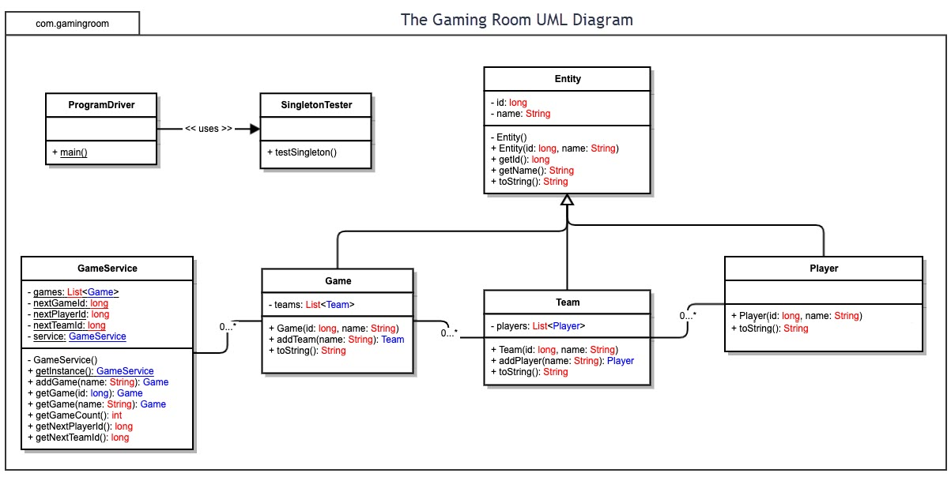

## Evaluation

Using your experience to evaluate the characteristics, advantages, and weaknesses of each operating platform (Linux, Mac, and Windows) as well as mobile devices, consider the requirements outlined below and articulate your findings for each. As you complete the table, keep in mind your client’s requirements, and look at the situation holistically, as it all must work together.

In each cell, remove the bracketed prompt and write your own paragraph response covering the indicated information.

| **Development Requirements** | **Mac** | **Linux** | **Windows** | **Mobile Devices** |
| --- | --- | --- | --- | --- |
| **Server Side** | MacOS server was built for businesses, home offices, and schools and designed to work best with other mac products. Apple has made the installation, setup, and management of the server as simple as possible. MacOS servers fully support resources made by Apple. MacOS servers do have their disadvantages such as their high price and high energy cost. MacOS servers also have trouble with resource used by many Windows developer programs but if your team uses Apple products for development then this should not be a problem. When hosting a web-based software on a Mac server the software will work fine with no different in preforms but will cost more for upkeep and energy cost. | Linux servers are open source this means that the code can be modified and updated to serve any prepose. Linux is also free, so the host only needs to pay for support for installation and upkeep. Linux servers can run Windows software, but they need to pay for interface software. They tend to use less resources compared to other servers as they are designed to run using lower power threshold. Due to Linux servers tending to use less resources this typically makes then more stable when in use. Linux servers do have disadvantages besides pay for any Windows license fee, due to a large amount software not being compatible with Linux patches may have to be build or installed to run the software. | Windows servers were built to handle Windows applications without need to troubleshoot. Windows servers are considered a quick and easy setup. If the development team needs to access the server from outside of work remote desktop access without command line programming is available. If the web-based software uses scripting frameworks, they can be run on the Windows server. If the server must have a database running this can be done using Microsoft SQL. Windows also has a customer support service for their servers. Windows server do come with their disadvantages such as not working well with Apple and Linux software but there are work arounds for most problems. | Mobile servers are built for more stable speeds and connections. The disadvantage of running a mobile server is that it becomes obsolete very fast causing a large upkeep and bandwidth limitations. The advantages of mobile servers include scalability due to mobile server being more update than most servers it can handle larger groups of devices, security because of the encryption used to send information from these servers, and data management due to the constant updating of the hardware newer drives are add with newer connects installed. These servers’ cost is the greatest of the four with constant update the hardware because of this many cloud hosting companies have come out. This has led to must companies using this service to handle the server to cut cost. |
| **Client Side** | Mac servers can cost between $6000 to $7000 for one brand new server. Apple has also made it so you can turn an old mac into a server. Apple has created MacOS X to be used for servers as well as normal computers. The time it takes to set up this server has decreased over the years at this time the setup is simple. Technical support for this server will be needed and continued in the future. | Linux servers can cost between $500 to $7000 for one server. Linux has many different operating software such as CentOS and Red Hat. The time needed for set up differs counting on the operating software however both CentOS and Red Hat have stated that the installation takes very little time. If the server needs any software add to the server, the installation many take longer and securing the operating software may also take time. | Windows servers can cost $6000 or more. Windows states that their new operating software is simple and can be easily set up. The software will take more time if any software needs to be installed. The server will need technical support to set up and after to maintain its ability to run. If the clients use Windows operating software and Windows software, no software will be needed to install. | Mobile servers can cost $1500 or more and need to be constantly updated with new hardware and software. The time it takes to set up a mobile server can change counting on size and structure of the network. The server will need technical support throughout its install and use. The server will need lots of maintains and will need to provide a stable connection to be useful. The software for the server will have to be always up to date to ensure that any problems will be taken care fast. |
| **Development Tools** | When creating a web page or web-based software for a Mac server the most used in JavaScript do to its easy to learn and develop on nature. The IDE used for this is Atom because of its easy-to-use tools and how it shows error in code so well. However, Mac’s can also handle Python, Java, PHP, Ruby, and many more. At this point in time almost every IDE that can be used on a Windows system can also be used on a Mac. | When creating a web page or web-based software for a Linux server the sky is the limit. Linux is able you use and run any language from C, C++, Python, Java, and many more. However, when looking into the best language for program a web-based game, JavaScript has the best tools for the job. The IDE for this is Eclipse due to its ability to run on Mac, Windows, and Linux. | When creating a web page or web-based software for a Windows server you can program in any language you want. However, it is recommended to us JavaScript due to its tools and IDE can handle web-based games. The best IDE for Windows is Eclipse due to its ability to work with Mac and Linux making it so that it works on any operating system. | When creating a web-based software for a mobile server you can program in JavaScript, Google Go, and many more. However, because this is a web-based software JavaScript would be the best choose due to its ability to work with any operating system and has many tool in its IDE Eclipse this would make it the software compatible with all user on any device. |

## Recommendations

Analyze the characteristics of and techniques specific to various systems architectures and make a recommendation to The Gaming Room. Specifically, address the following:

1. **Operating Platform**: The Gaming room requires an operating platform to expand their mobile app Draw It or Lose It, that can handle a large database of images used in game and handle running the game over the web. The operating platform will need to be able to handle multiple users and multiple game instances. It is always recommended to say with the same operating platform so that continuity is keep between the mobile app and the web-based version of the app. While keeping this in mind Microsoft Windows servers would be the best choose for the Draw It or Lose it web-based version.
2. **Operating Systems Architectures**: Microsoft Windows servers architecture has 3 major components external protocols, database engine, and SQLOS API. The external protocol works with shared memory, named pipes, TCP/IP, and virtual interface adapter. The external protocol’s main job is to handle how data is send and received and from where. The database engine has two major parts the storage engine and the relation engine. The database engine main job is to management of writing, reading, updating, and deleting from the server. The storage engine handles transaction servers, file manager, buffer manager, lock manager, and Utilities such as Backup and Restore. The relation engine handles Parser, Optimizer, SQL manager, database manager, and query executor. The SQLOS API handles synchronization services, thread scheduler, buffer pool, memory manager, I/O manager, worker threads, CLR, and MDAC. The SQLOS API is how the server connects to other operating systems.
3. **Storage Management**: The best storage management for the web-based Draw It or Lose It and its database would be HDD with RPM of 7200 due to its read and write speeds being 80-160MB/s this would allow the images of 8Mbs to be read fast and any data would be easy accessed like the score board. Testmy.net says that the world average download speed is 52Mbps as of 2021 which is below the speed of the 7200 RPM HDD. This will allow the game to download at the same speed for the average user. The Microsoft server can use this and more HDD using the storage engine using file manager, buffer manager, a long with Utilities to Backup and Restore any files that may get corrupted by drive failure or use a second HDD would be recommended in case of failure in the future.
4. **Memory Management**: Microsoft servers allow for many different tools to be used to manage memory. Microsoft servers us VMM Windows Virtual Memory Manager which manages memory for the server. VMM keeps the buffer pool from being too big that the system needs more memory to run the system. VMM also manages the physical I/O to the files in the database. VMM by default manages the system to run at its fastest. Microsoft allows the owner of the server to download many different memory managers, but the VMM will handle the game. VMM also allows the over-commitment of the physical memory allow the server to run on computers that should not be compatible with the server. Microsoft servers also use SQL architecture to help manage memory and how it is used in the server.
5. **Distributed Systems and Networks**: To ensure that all operating systems can work with Draw It or Lose It using a language they all understand is crucial. For example, both Microsoft Windows, Linux, and Mac understand JavaScript. Which would make it so that the user can use the app on any of the systems and the server understand JavaScript as well. Due to the Gaming Room wanting the game to be web-based hardware will not be a concern since web-based apps do not run on the client side but the server side making it so if the software understands the code there will be no problem running the app. Web-based games run through the web browser such as Microsoft Edge, Google Chrome, Safari, and Firefox. With all these browsers Java works so this will not be a problem. When it comes to the network side if we in sure that everyone playing the game is receiving the image at the same time there should not be a problem. However, if we want to ensure that the win is decide fairly when can check the clock of when the user entered their guess to see who answered first. This would ensure that the right person wins the round. All browsers allow for a stamp of time to be put on any message they enter allowing this check to be possible.
6. **Security**: Microsoft servers provide protection for data and apps along with the operating system. The 2019 Microsoft server has enchanted security features such as updated security from breaches, virus, and threats. Microsoft is also updating the system when new problems come to light. The server has built in protection from network attacks using Windows Defender Advanced Threat Protection. The server allows for encryption of all data on the server allowing no one to read the file or information easily. JavaScript can also encrypt all inputs and outputs using the encrypt method and can also decrypt be using the decrypt method. Both encryptions would ensure that security for the program would be held and as long as the server is updated any new method of attack would be handled.